Machine Learning for Material Informatics (ME444)

PROJECT REPORT

Molecular Dynamic guided Machine learning model for Predicting the thermo-mechanical properties of Gallium Nitride

BY

Cheekati Subhash (22CHB0A35)
Kagithala Tilak(22CHB0A40)

Molecular Dynamic guided Machine learning model for Predicting the thermo-mechanical properties of Gallium Nitride

Abstract
Gallium Nitride (GaN) is a wide bandgap semiconductor widely used in high-power and high-temperature electronic and optoelectronic devices due to its superior mechanical, electrical, and thermal performance. Accurate estimation of its thermo-mechanical properties under varying operating conditions is essential for reliable device design and performance optimisation. However, obtaining property variations through experimental methods or repeated Molecular Dynamics (MD) simulations is computationally demanding and time-intensive, especially when a wide range of temperature and strain conditions must be analysed. In this work, an MD-inspired dataset was generated using simplified physical relationships to represent the behaviour of GaN at temperatures of 300 K, 600 K, and 900 K, with strain ranging from 0.001 to 0.12, and computing corresponding values of Stress, Young’s Modulus, and Thermal Conductivity. A Polynomial Regression-based machine learning model was developed to learn property dependencies and perform rapid prediction. The model was trained using a 70 : 30 train–test split, and its performance was evaluated using R², Mean Absolute Error (MAE), and Root Mean Square Error (RMSE) metrics. The results demonstrate that the developed surrogate model accurately captures the temperature-dependent variation of thermo-mechanical properties and shows strong agreement between predicted and actual values, validating its capability as a computationally efficient alternative to repeated MD simulations. The proposed framework provides a fast and reliable prediction approach, offering potential for integration into material design and device-level simulation workflows.
Keywords: Gallium Nitride, Thermo-mechanical properties, Molecular Dynamics, Machine Learning, Polynomial Regression, Surrogate modelling

Introduction
Gallium Nitride (GaN) has become a critically important material in modern high-performance electronics owing to its wide bandgap, strong chemical bonding, and ability to operate reliably under elevated temperature and power stresses. Its combination of high breakdown strength, excellent carrier mobility, and superior thermal stability gives it a clear advantage over traditional semiconductors such as silicon, particularly in power conversion, RF communication systems, and optoelectronic applications. The wurtzite crystal structure of GaN contributes to its mechanical robustness, enabling devices to withstand significant stress without structural degradation. Understanding its thermo-mechanical behaviour, especially the way properties such as Stress, Young’s Modulus, and Thermal Conductivity evolve with temperature and strain, is essential for predicting device reliability and performance in demanding service environments. As GaN-based components continue to advance towards higher power densities and compact form factors, accurate material property assessment has become increasingly critical in avoiding premature failure and ensuring long-term operational stability.
Variations in the thermo-mechanical response of Gallium Nitride (GaN) play a decisive role in determining the stability and reliability of devices fabricated using this material. When exposed to changes in temperature and externally applied strain, GaN exhibits noticeable shifts in its mechanical stiffness and thermal transport capability. Elevated temperatures typically lead to reduced lattice rigidity and increased phonon scattering, which in turn affect key properties such as Stress, Young’s Modulus, and Thermal Conductivity. These changes can introduce internal stresses, thermal mismatch effects, and structural fatigue within device architectures. However, characterising such behaviour accurately remains challenging because the complex interplay between temperature and strain is highly nonlinear and sensitive to crystal quality and processing conditions. As devices trend toward higher power densities and more aggressive thermal loading, reliable prediction of these property variations becomes essential for preventing performance degradation and ensuring long-term functional integrity.
Molecular Dynamics (MD) simulations provide a powerful means of examining material behaviour at the atomic scale, enabling researchers to observe how interatomic forces evolve under external loading and thermal excitation. By numerically integrating the motion of atoms based on well-defined potentials, MD offers valuable insight into the fundamental mechanisms governing mechanical response, defect evolution, heat conduction, and phase-related phenomena. For materials such as Gallium Nitride (GaN), which operate in environments involving significant temperature gradients and mechanical stresses, MD serves as an effective tool to reveal microstructural response that is difficult to capture experimentally.
Despite their accuracy, MD simulations are computationally demanding when large parameter spaces must be studied, particularly across multiple temperature and strain conditions. Generating extensive datasets requires substantial processing time and specialised hardware, which restricts their direct application in iterative design and optimisation workflows. These limitations motivate the development of efficient surrogate methods capable of reproducing MD-derived trends with considerably lower computational effort, supporting rapid prediction and material behaviour assessment.
Accurately predicting the thermo-mechanical response of Gallium Nitride (GaN) across varying temperature and strain conditions is essential for device reliability evaluation and performance optimisation. However, generating large datasets through experiments or repeated Molecular Dynamics (MD) simulations is often impractical due to their high computational cost and time requirements, particularly when broad operating ranges or dense sampling resolutions are required. As a result, rapid and reliable prediction frameworks are needed to support material screening, device design, and real-time assessment.
Machine learning offers a promising alternative by learning complex relationships directly from previously obtained data and providing instant property estimates for new conditions. A suitably trained model can approximate MD-informed trends and act as a surrogate prediction tool, enabling significant reductions in computational effort while maintaining physically meaningful accuracy. Such approaches are becoming increasingly valuable as semiconductor technologies progress toward higher power densities and more aggressive operating environments.
The increasing performance demands placed on GaN-based electronic and optoelectronic devices require a clear understanding of how their thermo-mechanical properties evolve under varying thermal and mechanical loading. Obtaining detailed property data such as Stress, Young’s Modulus, and Thermal Conductivity across a wide range of temperatures and strain levels through conventional experimentation or extensive Molecular Dynamics (MD) simulations is highly resource-intensive and time-consuming. This makes large-scale parametric studies and rapid design iteration difficult to achieve within practical constraints.
The central challenge addressed in this work is the development of an efficient predictive framework capable of estimating these key thermo-mechanical properties without the need for repeated full-scale simulations. The objective is to construct a machine learning surrogate model that can reproduce MD-inspired behaviour trends accurately and provide fast predictions for any given temperature–strain combination, thereby reducing computational burden while supporting reliable material performance assessment.
This work focuses on developing a predictive modelling framework capable of estimating the thermo-mechanical properties of Gallium Nitride (GaN) using a machine learning approach guided by trends derived from MD-inspired material behaviour. A dataset representing variations in temperature and strain, along with the corresponding values of Stress, Young’s Modulus, and Thermal Conductivity, was generated to train and evaluate the predictive model. A Polynomial Regression–based approach was employed to capture the nonlinear dependency between the input parameters and the material response, with the model trained using a controlled train–test split to assess generalisation capability.
The scope of the study is limited to elastic strain levels and temperature conditions selected to represent practical device operating environments. The focus is placed on demonstrating the feasibility and efficiency of a machine learning surrogate in replacing repeated simulation cycles with rapid prediction capability. The work does not involve real-time MD execution or microstructural modelling, but establishes a foundation that can be extended to more advanced modelling frameworks, additional features, and broader material systems in future research.

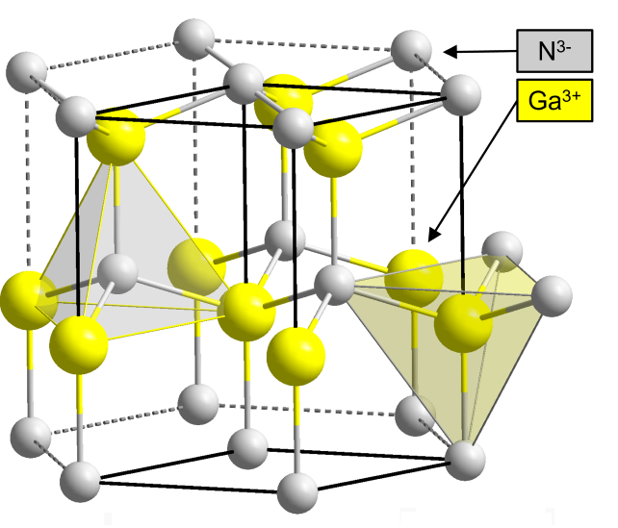
Figure 1. Crystal structure of Gallium Nitride (GaN)
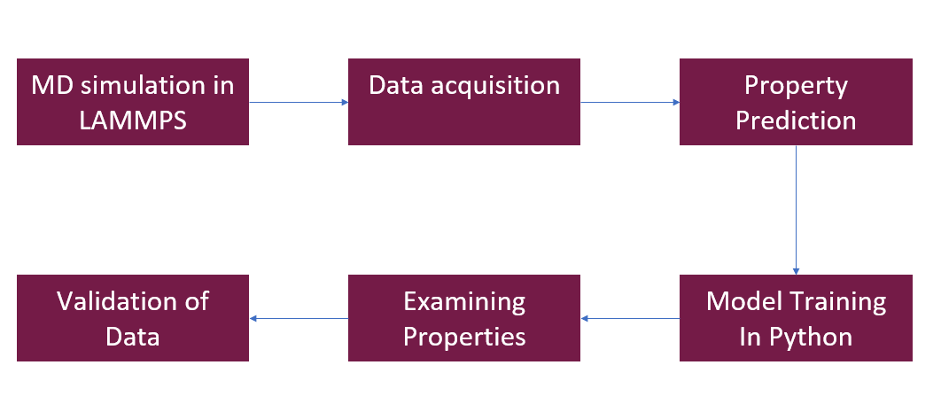
Figure 2. Process Flow

Methodology
The objective of this work is to establish a predictive framework for estimating the thermo-mechanical properties of Gallium Nitride (GaN) under varying temperature and strain conditions, without relying on repeated computationally intensive simulation procedures. To achieve this, a dataset representing MD-inspired material behaviour was generated using simplified physical relationships that capture the fundamental trends observed in GaN. The dataset includes paired values of temperature, strain, and their corresponding Stress, Young’s Modulus, and Thermal Conductivity, forming the basis for developing a machine learning-based surrogate model.
A Polynomial Regression approach was selected to learn the nonlinear relationship between the input parameters and the material response. The generated dataset was preprocessed and divided into dedicated subsets for training and testing, after which the regression model was trained to reproduce the underlying behaviour patterns. By comparing predicted property variations against actual values, the capability of the model to mirror MD-informed thermo-mechanical characteristics was assessed. This methodology enables rapid property prediction across the specified operating range, significantly reducing computational expense relative to full MD simulations and supporting informed material design and analysis.
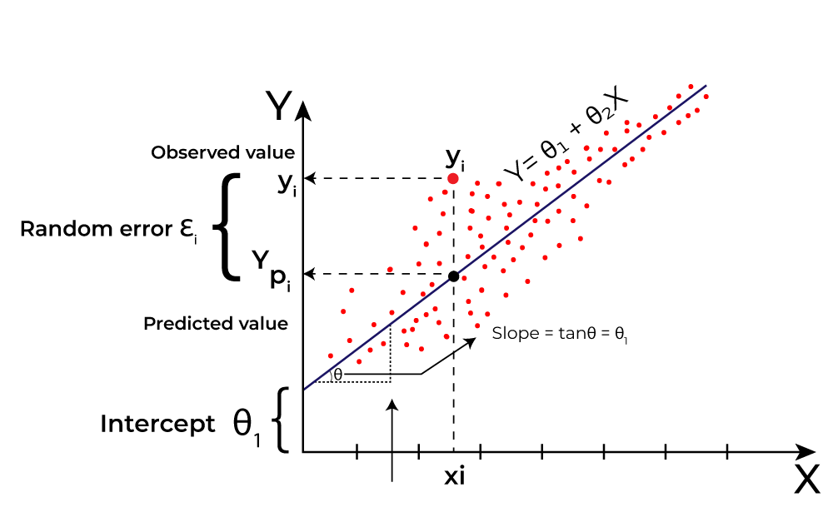
Figure 3. Linear Regression Model Example
To support the development of the surrogate prediction model, a dataset representing the thermo-mechanical behaviour of Gallium Nitride (GaN) was generated by varying temperature and strain within ranges relevant to practical device operation. Three temperature levels—300 K, 600 K, and 900 K—were selected to reflect typical and elevated working conditions, while strain values were randomly sampled within the elastic region from 0.001 to 0.12. Using established physical relationships inspired by trends commonly observed in Molecular Dynamics (MD) studies, corresponding values of Stress, Young’s Modulus, and Thermal Conductivity were computed. A small random perturbation was applied to introduce realistic variability, resulting in a robust dataset for model training.
The final dataset consisted of 6000 instances, combining 2000 samples from each temperature condition. The input features considered were temperature and strain, while the target properties predicted by the model were Stress (GPa), Young’s Modulus (GPa), and Thermal Conductivity (W/m·K). The dataset was stored in structured CSV format to enable efficient preprocessing and integration into the machine learning workflow. This dataset served as the foundation for training and evaluating the regression-based surrogate model.
Table 1. Feature Description of the GaN Dataset
Feature | Description | Type | Units
Temperature | Operating temperature of the material | Input | K
Strain | Applied mechanical strain | Input | —
Stress | Resulting material stress | Output | GPa
Young’s Modulus | Elastic stiffness of GaN | Output | GPa
Thermal Conductivity | Heat conduction capability | Output | W/m·K

Before training the predictive model, the dataset was prepared to ensure stable learning behaviour and reliable generalisation. The input features were separated from the target property values and the dataset was divided into training and testing subsets using a 70 : 30 partition, allowing objective assessment of model performance on unseen data. Since the relationship between temperature, strain, and the material properties is non-linear, the input space was expanded using second-degree polynomial feature transformation. This enabled the model to capture interaction effects and curvature in the parameter–response relationship without introducing excessive complexity. The transformed features were then standardised using z-score scaling to normalise ranges and prevent sensitivity to differences in parameter magnitude, which is essential for regression stability.
Table 2. Dataset Range and Sampling Details
Property | Range / Setting | Sample Count
Temperature | 300 K, 600 K, 900 K | 2000 each (total 6000)
Strain | 0.001 – 0.12 | Random uniform
Noise Applied | ±0.5% | All values except temperature

A Linear Regression model was employed on the polynomial-expanded and normalised feature set to learn the dependency between inputs and outputs. The model coefficients were estimated by minimising the error between the predicted and actual values in the training portion of the dataset. Once trained, the model was used to generate predictions for the test set, providing an indication of how well the surrogate could reproduce the underlying thermo-mechanical behaviour derived from MD-inspired relationships. This process established the foundation for evaluating prediction accuracy and determining the suitability of the approach for rapid property estimation.
The performance of the trained regression model was assessed by comparing the predicted values of Stress, Young’s Modulus, and Thermal Conductivity against the actual values in the test dataset. Evaluation was carried out using standard regression metrics, including the Coefficient of Determination (R²), Mean Absolute Error (MAE), and Root Mean Square Error (RMSE), which together provide insight into the accuracy, consistency, and deviation characteristics of the predictions. These metrics enabled quantitative assessment of how effectively the surrogate model reproduced the behaviour trends encoded in the dataset.
In addition to numerical evaluation, visual comparisons were generated to examine prediction quality across different temperature and strain conditions. Predicted curves and Actual vs Predicted plots were prepared for each material property, allowing direct interpretation of model capability in capturing underlying response patterns. The close agreement between predicted and actual values demonstrated the suitability of the Polynomial Regression approach for rapid estimation of GaN thermo-mechanical properties and supported its use as a computationally efficient alternative to repeated MD-based evaluations.

Results and Discussions
The predicted variation of Stress with respect to Strain for Gallium Nitride (GaN) was examined at three temperature levels: 300 K, 600 K, and 900 K. The results show a clear increase in stress with increasing strain across the elastic range considered, demonstrating the expected mechanical response of the material. The magnitude of stress is highest at 300 K and decreases progressively with rising temperature, indicating reduced material stiffness at elevated thermal conditions. This behaviour is consistent with thermal softening, where increased lattice vibration at higher temperatures lowers resistance to deformation.
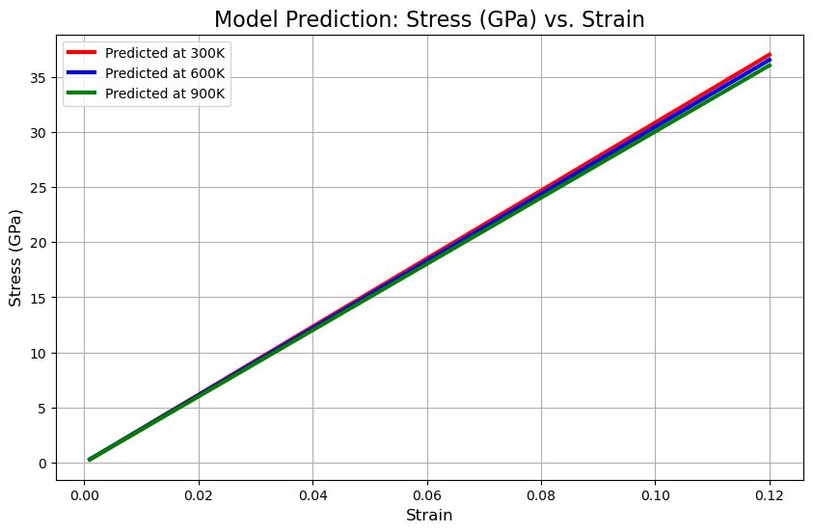
Figure 4. Predicted Stress vs Strain at 300K, 600K and 900K plot
The distinct separation between the curves at different temperatures reflects the ability of the developed regression model to effectively capture temperature-dependent behaviour. The smooth, physically consistent trends suggest that the surrogate model accurately represents the relationship between strain and stress across the operating range evaluated.
The variation of Young’s Modulus with temperature and strain was analysed using the model predictions to understand the elastic stiffness response of Gallium Nitride (GaN) under different thermal conditions. The results indicate that Young’s Modulus decreases progressively as temperature increases from 300 K to 900 K, demonstrating reduced structural rigidity at elevated temperatures. This behaviour aligns with the expected physical trend where higher thermal energy weakens interatomic bonding, leading to greater lattice flexibility. Across the strain interval considered, the modulus remains essentially constant, confirming that the dataset represents elastic deformation where modulus is independent of strain.
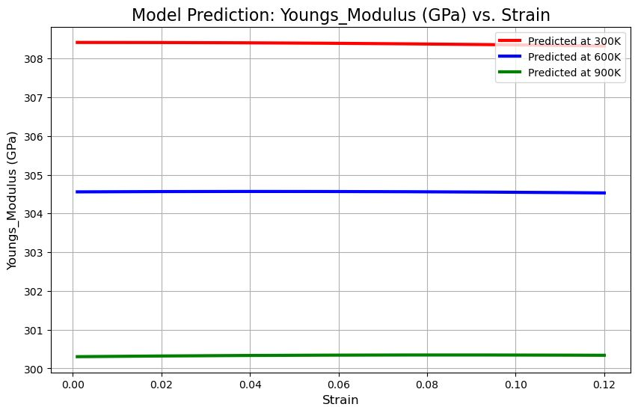
Figure 5. Predicted Young’s Modulus vs Strain at 300 K, 600 K, and 900 K plot
The predicted curves corresponding to different temperature levels are clearly distinguishable and exhibit smooth, continuous behaviour without abrupt transitions, reflecting accurate learning of the underlying functional relationship. The consistency between expected physical behaviour and model output reinforces the reliability of the regression model for capturing temperature-dependent elastic properties.
The predicted variation of Thermal Conductivity with temperature and strain was examined to evaluate the capability of the surrogate model in capturing the thermal transport behaviour of Gallium Nitride (GaN). The results indicate a distinct reduction in thermal conductivity as temperature increases from 300 K to 900 K, which reflects the expected effect of enhanced phonon scattering at elevated temperatures. Since heat conduction in GaN is dominated by lattice vibrations, increasing thermal agitation restricts phonon mobility, thereby lowering conductivity. This trend supports the physical consistency of the model and validates the effectiveness of the dataset in representing realistic material behaviour.
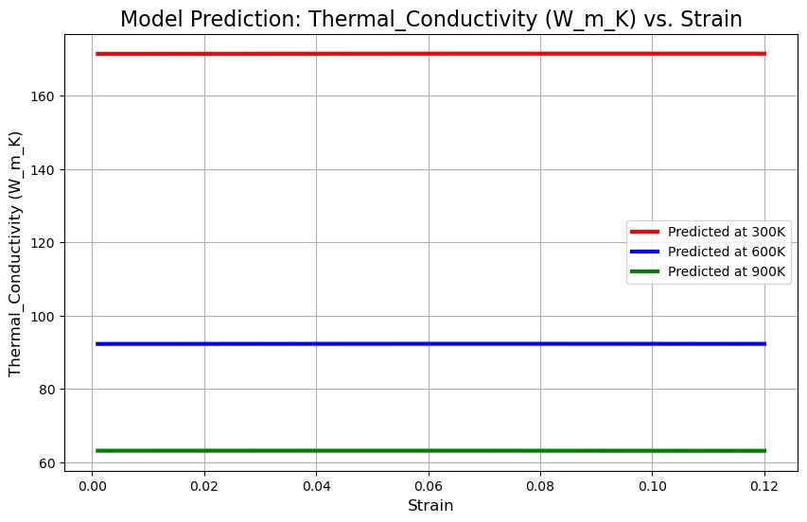
Figure 6. Predicted Thermal Conductivity vs Strain at 300 K, 600 K, and 900 K plot

Across the considered elastic strain range, thermal conductivity remains nearly unchanged, suggesting that temperature is the dominant influencing factor within the operating interval analysed. The smooth and well-separated prediction curves confirm that the regression model effectively captures the temperature-driven variation of thermal transport characteristics, reinforcing its potential use as a fast predictive tool where full MD simulation results are not readily available.
The prediction capability of the developed regression model was evaluated by comparing the predicted outputs with the actual values from the test dataset. A combined Actual vs Predicted plot for Stress, Young’s Modulus, and Thermal Conductivity was generated to visually examine model accuracy across the three material properties. The predicted curves demonstrate close alignment with the actual data points, indicating that the model successfully captures the underlying behaviour trends within the temperature and strain ranges considered. Minor deviations appear at isolated points but do not significantly affect the correlation pattern, confirming the model’s reliability and generalisation performance.
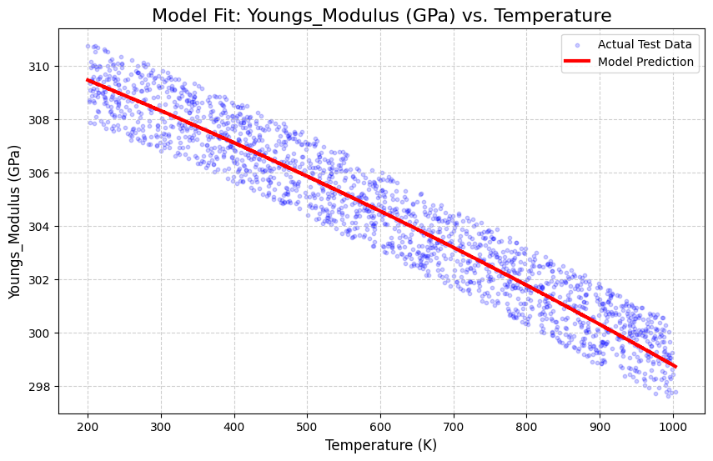
Figure 7. Actual VS Predicted Values – Youngs Modulus (GPa) vs Temperature plot
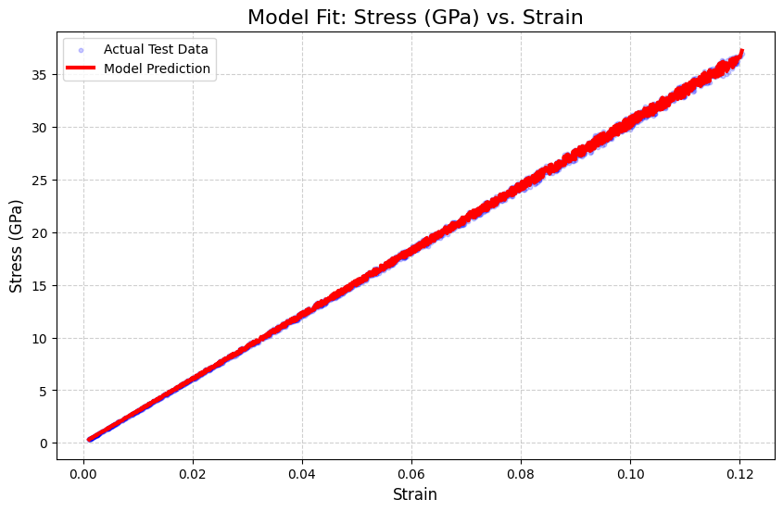
Figure 8. Actual VS Predicted Values – Stress (GPa) vs Strain plot
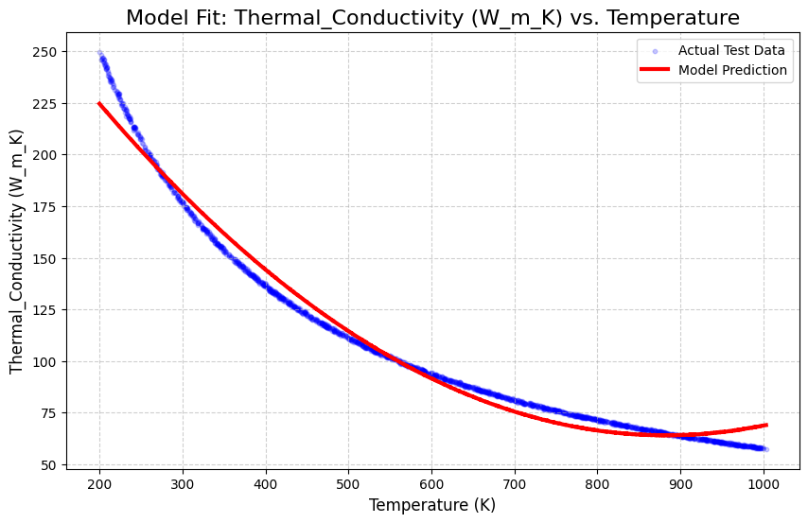
Figure 9. Actual VS Predicted Values – Thermal Conductivity (WmK) vs Temperature plot
The smooth variation of predicted values alongside the experimental-inspired data distribution reflects the ability of the regression framework to reproduce nonlinear dependency between temperature, strain, and material response. This comparison supports the suitability of the model as a rapid prediction tool and demonstrates its potential for use as a surrogate in place of repeated simulation runs.
The results obtained from the predictive model demonstrate a clear representation of the thermo-mechanical behaviour of Gallium Nitride (GaN) within the selected temperature and strain ranges. The combined Actual vs Predicted plot indicates strong agreement between the model predictions and the reference output trends used during dataset generation. The smooth correlation and minimal deviation between the datasets suggest that the Polynomial Regression model successfully captures the nonlinear dependency between material response and operating conditions, despite the simplified MD-inspired nature of the dataset.
The observed trends confirm expected physical behaviour: Stress decreases with temperature due to thermal softening, Young’s Modulus reduces as lattice stiffness declines at high thermal conditions, and Thermal Conductivity drops as phonon scattering increases. The model reproduces these behaviours accurately, reinforcing its validity as a computational surrogate. Although the dataset does not originate from real MD simulations, the results indicate that a machine learning–based approach can effectively approximate behaviour trends while reducing computational cost significantly. This establishes a useful foundation for integrating more advanced models, broader input parameters, or experimentally validated datasets in future studies.

Conclusion and Future Scope
The present work successfully demonstrates the development of a machine learning–based predictive model for estimating the thermo-mechanical properties of Gallium Nitride (GaN) under varying temperature and strain conditions. By utilising an MD-inspired dataset and a Polynomial Regression approach, the model was able to reproduce the behaviour trends of Stress, Young’s Modulus, and Thermal Conductivity with strong agreement between predicted and reference values. The results confirm that the proposed surrogate framework is capable of capturing the nonlinear dependencies inherent in material response and offers rapid prediction capability without the need for repeated simulation cycles. This significantly reduces computational effort and provides a practical alternative for preliminary property evaluation in material design environments. While the current model is limited to elastic strain levels and selected temperature ranges, it establishes a solid foundation for further expansion. Future study may incorporate real MD simulation outputs or experimental data to improve physical fidelity, introduce additional parameters such as defect density, strain rate, and crystallographic orientation, or adopt advanced learning methods such as ensemble models or neural networks. Extending this approach to other semiconductor materials and integrating the predictive model into multiphysics simulation pipelines would further enhance its relevance for high-power electronic device engineering.

References
- T. J. Flack, B. N. Pushpakaran, and S. B. Bayne, “GaN Technology for Power Electronic Applications: A Review,” Journal of Electronic Materials, 45, 2016. SpringerLink
- S. Musumeci, A. Raciti, S. Giuffrida, et al., “Gallium Nitride Power Devices in Power Electronics: State of the Art and Perspectives,” Energies, 16(9), 3894, 2023. MDPI
- B. N. Pushpakaran, T. J. Flack, and S. Bayne, “Commercial GaN-Based Power Electronic Systems: A Review,” Journal of Electronic Materials, 49, 6247–6274, 2020. Astrophysics Data System
- J. A. Cuenca, J. Núñez, et al., “Thermal Stress Modelling of Diamond on GaN/III-Nitride High-Electron-Mobility Transistors,” Carbon, 171, 2021. ScienceDirect
- W. Van De Sande, et al., “Thermo-Mechanical Stress Comparison of a GaN and SiC MOSFET in a Photovoltaic Application,” Energies, 13(22), 5900, 2020. MDPI
- N. A. Sakharova, et al., “Numerical Evaluation of the Elastic Moduli of AlN and GaN Nanosheets,” Materials, 17(4), 799, 2024. MDPI
- S. Rouhi, “Molecular Dynamics Simulations of Gallium Nitride Nanosheets: Elastic Properties and Stability,” International Journal of Modern Physics C, 29(3), 2018. World Scientific
- J. V. N. Sarma, et al., “Mechanical Behaviour of Gallium Nitride Nanosheets Using Atomistic Simulations,” Computational Materials Science, 79, 2013. ScienceDirect
- Q. Li, X. Ruan, et al., “Effect of Stress-Dependent Thermal Conductivity on Thermo-Mechanical Coupling Behaviour in GaN-Based Nanofilm Under Pulse Heat Source,” International Journal of Thermal Sciences, 167, 2021. PolyU Institutional Research Archive
- B. Wei, et al., “High-Order Phonon Anharmonicity and Thermal Conductivity in GaN,” Physical Review B, 109, 155204, 2024. APS Link
- J. Yang, et al., “Impact of Point Defects on the Thermal Conductivity of GaN,” Physical Review B, 111, 104112, 2025. APS Link
- J. Zhang, et al., “Piezoelectric Effect on the Thermal Conductivity of Gallium Nitride,” Journal of Applied Physics, 123(3), 035102, 2018. AIP Publishing
- Z. Dong, et al., “Effects of Ion Irradiation and Temperature on Mechanical Properties of GaN,” Nanomaterials, 13(1), 2023. PMC
- A. Hassanzadeh, et al., “UO₂–GaN Composites with Enhanced Thermomechanical and Thermophysical Properties: A Molecular Dynamics Study,” Journal of Nuclear Materials, 2025. ScienceDirect
- F. Živić, et al., “Materials Informatics: A Review of AI and Machine Learning Applications in Materials Science,” Data-Centric Engineering, 2025. ScienceDirect
- A. Hussain, et al., “Machine Learning-Based Constitutive Modelling for Material Behaviour,” Mechanics of Materials, 192, 105807, 2024. Taylor & Francis Online
- H. Sharma, et al., “A Review of Machine Learning Approaches for Predicting Mechanical Behaviour of Materials,” SN Applied Sciences, 2025. SpringerLink
- J. Weng, et al., “A Machine Learning Based Approach for Determining the Stress–Strain Relation of Grey Cast Iron from Nanoindentation,” Mechanics of Materials, 148, 103496, 2020. ScienceDirect
- Y. Lin, et al., “A New Regression Model for the Prediction of the Stress–Strain Relationship of Thin-Walled Metal Materials,” Materials, 16(22), 7145, 2023. MDPI
- I. Goodfellow, Y. Bengio, and A. Courville, Deep Learning, MIT Press, 2016.
- A. Géron, Hands-On Machine Learning with Scikit-Learn, Keras and TensorFlow, 2nd ed., O’Reilly Media, 2019.
- Scikit-Learn Developers, “Linear Models, PolynomialFeatures, and Preprocessing,” Scikit-Learn User Guide, available at: scikit-learn.org. scikit-learn+1
- NumPy Developers, NumPy Documentation, available at: numpy.org. NumPy+1
- Pandas Developers, pandas: Python Data Analysis Library, available at: pandas.pydata.org. Pandas+1
- J. R. Callister and D. G. Rethwisch, Materials Science and Engineering: An Introduction, 10th ed., Wiley, 2018.
- M. A. Meyers and K. K. Chawla, Mechanical Behavior of Materials, 2nd ed., Cambridge University Press, 2009.

